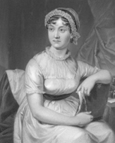

Travel and Tea with Jane Austen

You could visit the Or have tea using local

places she visited delicacies from the places

she knew

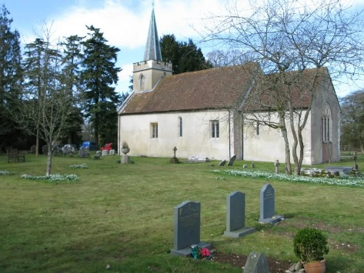Steventon, Hampshire Watercress, New Forest produce

where Jane was born

You can see the site of

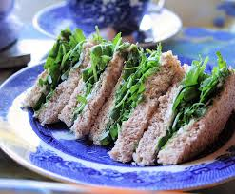the house where she

was born (it was demolished

in 1824) and the village church.

Her father was Rector of Steventon

or 40 years until his retirement in 1801.

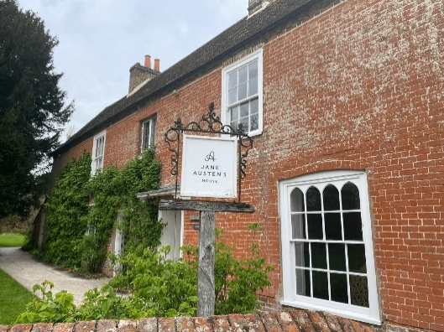

Chawton, Hampshire

where she lived. She

wrote and published

her novels when she lived

here. You can visit the house

and find information at

<https://janeaustens.house>

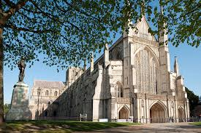Winchester

She spent the last weeks of her life

in Winchester and is buried in

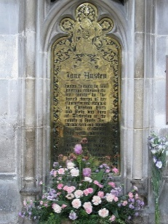Winchester Cathedral

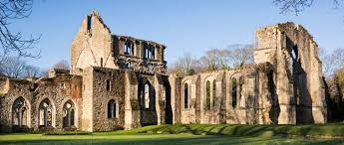Southampton, Hampshire

Jane liked walking to

Netley Abbey which is thought

to be the inspiration for

Northanger abbey.

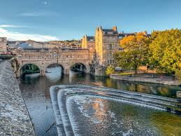Bath, Somerset where Jane Sally-Lunn Buns, Bath Buns, Bath Olivers

and her family moved to in Bath Chaps. Bath soft cheese

1801, after her father retired.

He died a few years later, but

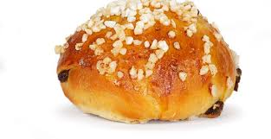Jane, along with her mother

and sister, stayed in Bath until

1806.

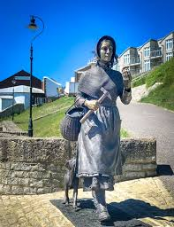Lyme Regis, Dorset Dorset Knob Biscuits, Dorset Apple Cake,

Jane visited twice, in Blue Vinny Cheese

1803 and 1804. She used

it as location for her

Novel Persuasion.

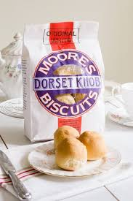

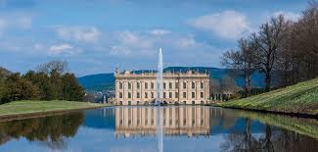Chatsworth House, Derbyshire Derbyshire Oatcakes, Bakewell Pudding, Jane visited Bakewell in 1811. Bakewell Tart, Fidget Pie, Hartington

There is no proof, but she is

believed to have visited

Chatsworth House

and used it 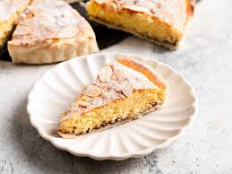as the inspiration for

Pemberley.

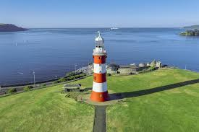Plymouth, Devon Clotted cream, Devon Splits, Devon pasties,

Between 1801 and 1804, crab and other sea food

Jane visited Devon.

[Saltram House](https://www.google.com/search?sca_esv=e2f8f01341ab6ed1&rlz=1C1MYPO_en-GBGB1176GB1176&cs=0&q=Saltram+House&sa=X&ved=2ahUKEwi6oNSrxMePAxVmR0EAHVnGAbgQxccNegQIAxAC&mstk=AUtExfC0__prEWF3oO2Pkqjg2W8Sx3GaLPA-MXzbnGK_YDcXG5beClhb_dGNVLZuMYQgvAIPxZDWS1cTV_H6mdeHQTSNn1F-3DtQZXuIJ6R-mYE7gY6hAJ68tF6nwV7vX0MJjxnTKf1AAlzRJpe2FPG3vyYcsKjJ7w6_NGCOZrWC8ZIPPEF7mJGY_wCqLzUn44VF3TMV&csui=3) in Plymouth

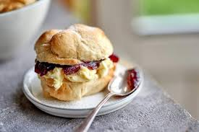was used as a location for

the Dashwood family

home in Sense and Sensibility.

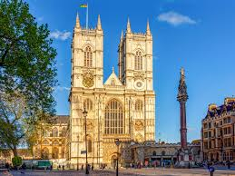Westminster Abbey, London Bourbon biscuits, Peach Melba, Scotch

Jane has a tablet to her memory egg, smoked salmon, Earl Grey Tea,

in Poet’s Corner in Westminster

Abbey. She visited London many

Times to visit her brother Henry.

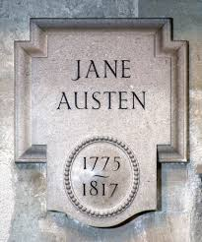She also visited her publisher

here.

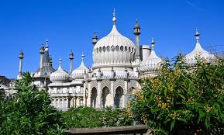Brighton, Sussex Sussex wine, Sussex Pond Pudding,

There is no evidence that Banofi Pie, Sussex Plum Heavies

Jane visited Brighton but she

included it Pride and Prejudice

and Mansfield Park.



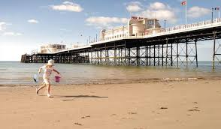Worthing, Sussex

Jane visited Worthing and

it inspired her unfinished

novel Sanditon in 1805

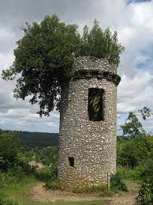Leatherhead, Surrey Norbury Blue cheese, Maids of Honour,

Jane Austen is thought to

have visited the area around

Leatherhead, Surrey, including

[Great Bookham](https://www.google.com/search?sca_esv=efb3ab264f9589fa&rlz=1C1MYPO_en-GBGB1176GB1176&cs=0&q=Great+Bookham&sa=X&ved=2ahUKEwjA56K6zsePAxVHZkEAHXSSDH4QxccNegQIBRAB&mstk=AUtExfBxvjQq84voQ9OwLX_P2oCvDo6VtT0S7mXvM2wUtM0mdWs5y03ih5toWRLYg_MPOHS83RR64oY-o2zimeWvfGCjZq5404Ss-hTAmvpQHnLFjyfMT6-P2PqFLi2SI4BfNS7Xlo0c4Gc9TkjwjuDmal0BzH5KLC8HyWmgkcDZtOFH0ZnCOuhF8DP8YcM6IBGIZEzuLtVPbZf5qBon_YokHqoTpz0DNwbP1UgmVOw2kD_z9g&csui=3) and [Box Hill](https://www.google.com/search?sca_esv=efb3ab264f9589fa&rlz=1C1MYPO_en-GBGB1176GB1176&cs=0&q=Box+Hill&sa=X&ved=2ahUKEwjA56K6zsePAxVHZkEAHXSSDH4QxccNegQIBRAC&mstk=AUtExfBxvjQq84voQ9OwLX_P2oCvDo6VtT0S7mXvM2wUtM0mdWs5y03ih5toWRLYg_MPOHS83RR64oY-o2zimeWvfGCjZq5404Ss-hTAmvpQHnLFjyfMT6-P2PqFLi2SI4BfNS7Xlo0c4Gc9TkjwjuDmal0BzH5KLC8HyWmgkcDZtOFH0ZnCOuhF8DP8YcM6IBGIZEzuLtVPbZf5qBon_YokHqoTpz0DNwbP1UgmVOw2kD_z9g&csui=3),

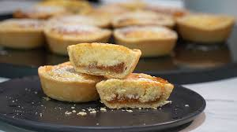When she was writing Emma

in 1814.

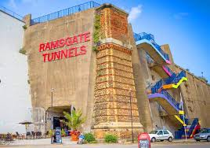Ramsgate, Kent Gypsy Tart, Canterbury Tart, Huffkins,

Jane visited Ramsgate in sandwiches, Folkestone Pudding Pie

1803 when she visited her

brother Frances. She also

stayed here with her brother

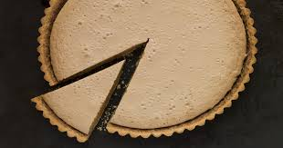Edward.

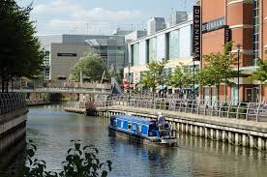Reading, Berkshire Biscuits, Eton Mess

Jane spent 18 months at school

in Reading between 1835

and 1836.